

3rd European Workshop on Equine Nutrition
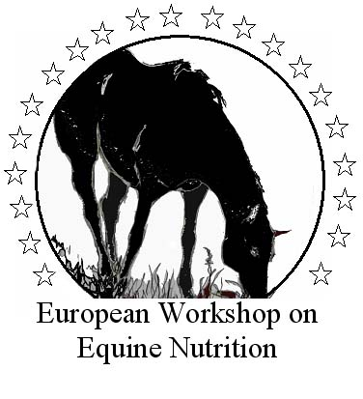

Nutrition and feeding of the broodmare

REGISTRATION
All participants who wish to attend the scientific programme are requested to fill in the registration form.
Advanced registration is preferred and will help to avoid delays at the time of the scientific programme.
All participants are kindly advised to pre-register before the Conference.
Registration is only valid on receipt of payment.
The total cost of registration fee must be sent in Euro.

3rd EWEN REGISTRATION FORM

Name____________________________________ First Name________________________________________

Institut/Company

Department

Address

Place

Zip Code

Telephone

Telefax

E-mail(obligatory)

FOR INVOICE IT IS NECESSARY TO ADD:

Place and date of birth

Fiscal Code(for Italian participants only)

Personal address:

3rd EWEN REGISTRATION FORM*

 | Before April 1st | After April 1st | Total
Participants | 300 | 400
Senior Researchers (over35 years) | 250 | 350
Young researchers(less than 35 years)* | 100 | 200
Students (less than 30 years old)*  including also: Phd Students-Post Graduated Students | free | 100
FISE(Italian Equestrian Federation) members | free | free
Daily fee  June 20th ◻  June 21st ◻  June 22nd ◻ | 100 | 150
Participation at the 8th National Congress “New Findings in Equine Practice”(June, 23rd) | free | 100
TOTAL

*in case of special rates a proof of status will be required

TOTAL AMOUNT TO PAY TO THE MOLISE UNIVERSITY: € _________________________

Date and signature _______________________________________________________________

The payment has to be made by bank transfer to:
Molise University – SAVA Department
Via De Sanctis
86100 Campobasso
Bank name: Banca di Roma, Agenzia n. 1500
Bank address: Piazza Guglielmo Pepe 32 – 86100 Campobasso(I)
Account number: 400.70
Cod. ABI: 3002
Cod. CAB: 03804
IBAN: IT13E002038040000000400.70
Swift Code: BROMITR1NC3
On the bank payment must be clearly indicated:
“3rd EWEN Registration – D. SAVA/Molise University”, followed by the name of the participant.
Please note that the Organizing Secretariat will not accept bank charges; bank charges are at the sender expenses. All unpaid bank charges will be charged on arrival.
Payment by credit card will be not accepted.
A registration certificate will be forwarded to the participants after the Organizing Secretariat has
accepted the registration form and confirmed receipt of the registration fee. On the day of the
conference this certificate should be presented to the Registration Desk.
No anticipated or invoice will be made before the Congress. For invoice it is necessary to fill in
the specific form.
Cancellation and refund policy. Cancellation can only be made in writing to the Organizing Secretariat.
Cancellation received before April 30th, 2006: 80% refund.
Cancellation received before may 31st, 2006: 50% refund.
Cancellation received after May 31st or no notice: no refund.
All refunds will be processed after the Meeting.
The registration is transferable to a colleague.
On site registration. A Registration desk will be available for participants at the Conference Venue.
Official letter of invitation. An official letter of invitation designed to overcome administrative difficulties will be sent on request. It must be understood that such letters does not grant any financial support.
Registration fee includes: Scientific sessions, Simultaneous translation English/Italian, Proceedings book, Congress bag, Lunches(June 20th 22nd ), Coffee breaks(June 20th , 22nd ), Welcome cocktail(June 20th ), Conference Tour(June 21st), Participation at the 8th National Congress “New Findings in Equine Practice”(June, 23rd) for advanced registrations.

Please complete the registration form and return it with copy of the bank transfer by mail or fax to:
Prof. Nicoletta Miraglia, Department of Animals, Vegetables and Environmental
Sciences, Molise University, Via De Sanctis - 86100 Campobasso(I)
Tel.: +39.0874.404696
Fax: +39.0874.404855
E-mail: miraglia@unimol.it

We will confirm systematically your registration by e-mail

